CheckQuick Corp. – Checkout System
Phase 1: Understand & Explore
Step 1: Analyze Requirements
1. Introduction
CheckQuick Corp. is an e-commerce platform that processes more than $150 million in transactions every month and serves approximately 5 million active users. The company is experiencing approximately $5.2 million in annual losses due to cart abandonment caused by slow and complex checkout processes.
The objective of the proposed system is to provide a fast, responsive, reliable, and simplified checkout experience. The system will use React for the frontend, FastAPI for REST APIs, PostgreSQL for transaction data, Redis for caching and session management, and other supporting technologies for scalability and performance.
The first step is to identify the major entities involved in the checkout process, their relationships, and the constraints that must be maintained.
2. Business Requirements
The checkout system should provide the following capabilities:
- Allow users to browse available products.
- Allow users to add products to their shopping cart.
- Allow users to update or remove cart items.
- Maintain accurate product inventory.
- Validate product availability before checkout.
- Allow users to provide or select a shipping address.
- Convert a valid cart into an order.
- Calculate the order total correctly.
- Process payments securely.
- Handle failed and successful payment attempts.
- Maintain order and payment status.
- Provide fast responses during checkout.
- Prevent invalid or duplicate transaction data.
- Support a large number of concurrent users.
3. Core Entities
The following entities have been identified for the checkout system.
Entity | Description
User | Stores customer account information
Product | Stores information about products available for purchase
Inventory | Tracks the stock quantity of each product
Cart | Represents a user's current shopping cart
CartItem | Stores individual products and quantities in a cart
Address | Stores customer shipping/billing addresses
Order | Represents a completed checkout transaction
OrderItem | Stores individual products belonging to an order
Payment | Stores payment attempts and their status

4. Entity Attributes
4.1 User
Attribute | Description | Key
user_id | Unique user identifier | PK
name | Customer name
email | Customer email | UNIQUE
password_hash | Encrypted/hashed password
phone | Customer phone number
created_at | Account creation time
updated_at | Last update time

4.2 Product
Attribute | Description | Key
product_id | Unique product identifier | PK
name | Product name
description | Product description
sku | Stock Keeping Unit | UNIQUE
price | Current product price
status | Product availability status
created_at | Product creation time
updated_at | Last update time

4.3 Inventory
Attribute | Description | Key
inventory_id | Unique inventory identifier | PK
product_id | Product being tracked | FK
quantity | Total available stock
reserved_quantity | Stock reserved for pending transactions
updated_at | Last inventory update

4.4 Cart
Attribute | Description | Key
cart_id | Unique cart identifier | PK
user_id | Owner of the cart | FK
status | Current cart status
created_at | Cart creation time
updated_at | Last cart update
expires_at | Cart/session expiration time

4.5 CartItem
Attribute | Description | Key
cart_item_id | Unique cart item identifier | PK
cart_id | Associated cart | FK
product_id | Associated product | FK
quantity | Number of units
unit_price | Product price when added to cart

4.6 Address
Attribute | Description | Key
address_id | Unique address identifier | PK
user_id | Address owner | FK
address_line | Street/address details
city | City
state | State
postal_code | Postal/ZIP code
country | Country

4.7 Order
Attribute | Description | Key
order_id | Unique order identifier | PK
user_id | Customer who placed the order | FK
shipping_address_id | Shipping address | FK
status | Current order status
total_amount | Total order value
created_at | Order creation time
updated_at | Last update time

4.8 OrderItem
Attribute | Description | Key
order_item_id | Unique order item identifier | PK
order_id | Associated order | FK
product_id | Purchased product | FK
quantity | Number of units purchased
unit_price | Price at time of purchase

4.9 Payment
Attribute | Description | Key
payment_id | Unique payment identifier | PK
order_id | Associated order | FK
payment_reference | Payment gateway reference | UNIQUE
amount | Amount paid/attempted
payment_method | Payment method
status | Payment status
created_at | Payment attempt time

5. Entity Relationships
User → Cart
A user can have an active shopping cart. A cart belongs to one user.
Relationship: 1 : 1 for the active cart

User → Order
A user can place multiple orders, but each order belongs to one user.
Relationship: 1 : M

User → Address
A user can save multiple addresses.
Relationship: 1 : M

Cart → CartItem
A cart can contain multiple products, represented by CartItem records.
Relationship: 1 : M

Product → CartItem
A product can appear in many different carts.
Relationship: 1 : M

Product → Inventory
Each product has inventory information used to track stock.
Relationship: 1 : 1

Order → OrderItem
An order can contain multiple products.
Relationship: 1 : M

Product → OrderItem
A product can appear in multiple orders.
Relationship: 1 : M

Order → Payment
An order can have multiple payment attempts, for example when the first payment fails and the customer retries.
Relationship: 1 : M

6. Checkout Process
The expected checkout process is:
User
↓
Browse Products
↓
Add Product to Cart
↓
Cart
↓
Update Quantity
↓
Proceed to Checkout
↓
Validate Cart
↓
Check Inventory
↓
Select Shipping Address
↓
Create Order
↓
Create Order Items
↓
Process Payment
↓
┌───────────────┐
│ Payment Result│
└───────┬───────┘
│
┌────┴────┐
↓ ↓
SUCCESS FAILED
↓ ↓
Confirm Allow
Order Retry
The system should ensure that inventory and payment information remain consistent throughout this process.

7. Database Constraints
User Constraints
- user_id must be unique.
- Email must be unique.
- Email must be valid.
- Required fields must not be NULL.
- Password must be stored as a hash rather than plain text.
Product Constraints
- SKU must be unique.
- Product price must be greater than zero.
- Product status must contain a valid value.
Example:
price > 0
Inventory Constraints
- Quantity cannot be negative.
- Reserved quantity cannot be negative.
- Reserved quantity should not exceed available stock.
- Every inventory record must reference an existing product.
Cart Constraints
- Every cart must belong to a valid user.
- Cart item quantity must be greater than zero.
- A product should not occur more than once in the same cart.
Example:
UNIQUE(cart_id, product_id)
Order Constraints
- Every order must belong to an existing user.
- Every order must contain at least one order item.
- Total amount cannot be negative.
- Order item quantity must be greater than zero.
- The unit price should be stored in OrderItem so that historical order prices do not change when the product's current price changes.
Payment Constraints
- Payment amount must be greater than zero.
- Every payment must reference an existing order.
- Payment reference should be unique.
- Payment status should be restricted to valid values.
Possible statuses:
PENDING
SUCCESS
FAILED
REFUNDED

8. Performance Requirements
Since CheckQuick handles millions of active users and a large transaction volume, performance is an important requirement.
Indexes should be considered for frequently queried fields such as:
- User.email
- Product.sku
- Cart.user_id
- CartItem.cart_id
- Order.user_id
- Order.status
- Payment.payment_reference
Redis can later be used for:
- User sessions
- Cart/session caching
- Frequently accessed product information
- Temporary checkout data
PostgreSQL will remain the primary source of truth for transactional data.

9. Payment Processing Constraints
Payment processing must be reliable because duplicate or inconsistent payments can cause financial problems.
The system should:
- Generate a unique payment reference.
- Prevent duplicate payment processing.
- Record every payment attempt.
- Support successful and failed payments.
- Allow payment retry after failure.
- Update the order only after successful payment confirmation.
- Avoid exposing sensitive payment information through API responses.

10. Inventory Management Constraints
Inventory must be checked before completing an order.
For example, if a product has:
Available stock = 10
Customer requests = 4
The checkout can proceed.
If:
Available stock = 3
Customer requests = 4
The checkout must be rejected because sufficient inventory is unavailable.
The system should also prevent two simultaneous customers from purchasing the same final units of stock.

11. Session Management
Checkout sessions should be maintained efficiently.
A session may contain information such as:
- User identification
- Cart identification
- Checkout progress
- Selected address
- Temporary checkout state
Redis can be used to store session information because it provides fast in-memory access.
Expired sessions should also be removed automatically.

12. ER Diagram
The following ERD represents the proposed database structure:
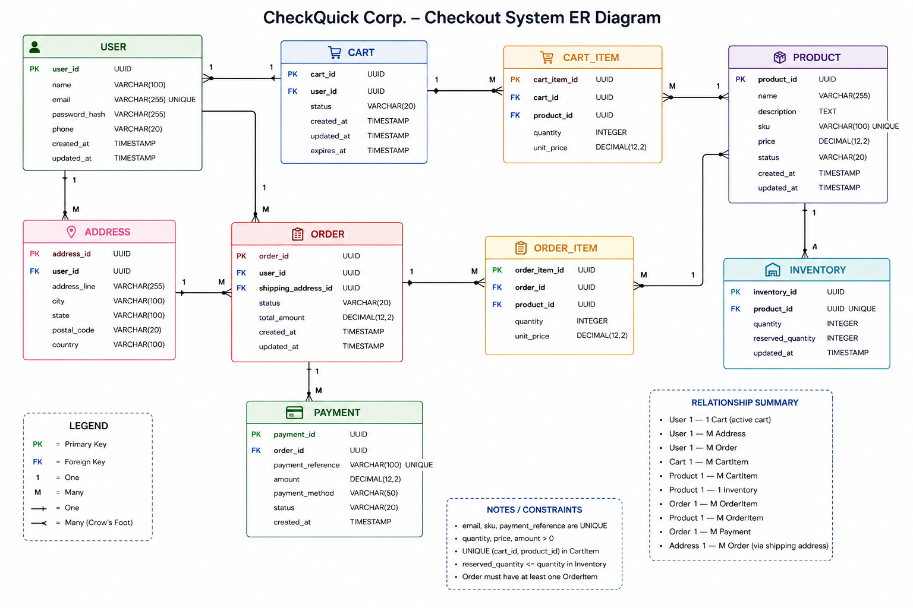
13. Key Findings
The requirement analysis identified several important factors that influence the checkout system.
1. Checkout speed
The checkout process must minimize unnecessary API calls and database queries because slow checkout contributes to cart abandonment.
2. Data consistency
Orders, payments, and inventory involve financial transactions and therefore require strong database consistency.
3. Inventory accuracy
Inventory must be validated and updated safely to prevent overselling.
4. Payment reliability
Payment failures should not result in incorrect order states. Payment retries should be supported.
5. Scalability
The architecture should support millions of users and high transaction volumes.
6. Caching
Redis can reduce repeated database queries and improve session/checkout performance.
7. Database indexing
Frequently queried fields should be indexed to maintain query performance as the database grows.
8. Validation
Invalid quantities, prices, emails, payment values, and other malformed data should be rejected before reaching the database.

14. Summary
The proposed CheckQuick checkout system consists of nine core entities: User, Product, Inventory, Cart, CartItem, Address, Order, OrderItem, and Payment.
The User entity is connected to carts, orders, and addresses. Carts contain cart items, while orders contain order items. Both cart items and order items reference products. Products are associated with inventory, and orders are associated with payment attempts.
The system must enforce constraints related to product availability, inventory quantities, order totals, payment status, unique identifiers, and user data. PostgreSQL will provide reliable transactional storage, while Redis can be used for high-speed session and caching requirements.
This analysis provides the foundation for the next phase, Database Schema Design, where these entities will be converted into normalized PostgreSQL tables with primary keys, foreign keys, constraints, and indexes.

15. Deliverables Checklist
Deliverable | Status
Identify core entities | Completed
Define entity attributes | Completed
Define relationships | Completed
Identify business constraints | Completed
Analyze checkout process | Completed
Analyze payment constraints | Completed
Analyze inventory constraints | Completed
Analyze session requirements | Completed
ERD | Completed
Summary report | Completed

